<html>

<head>

<title> ITC5202 - Week 13 </title>

<script src="https://ajax.googleapis.com/ajax/libs/jquery/3.3.1/jquery.min.js"></script>

<script>

$(document).ready(*function*() {

$.ajax({

url: "MyData1.json",

success: *function*(*data*) {

console.log(*data*);

},

error: *function*(*data*) {

console.log("Requested resource does not exist");

}

});

});

</script>

</head>

<body>

<p id="demo"></p>

</body>

</html>

1. $.ajax which is used to perform an asynchronous javascript and xml call to the server from the client (browser). It requests for a resource called MyData1.json and also has defined a callback function, the promise of which only resolves when the request done by the client returns a HTTP OK response (status = 200).

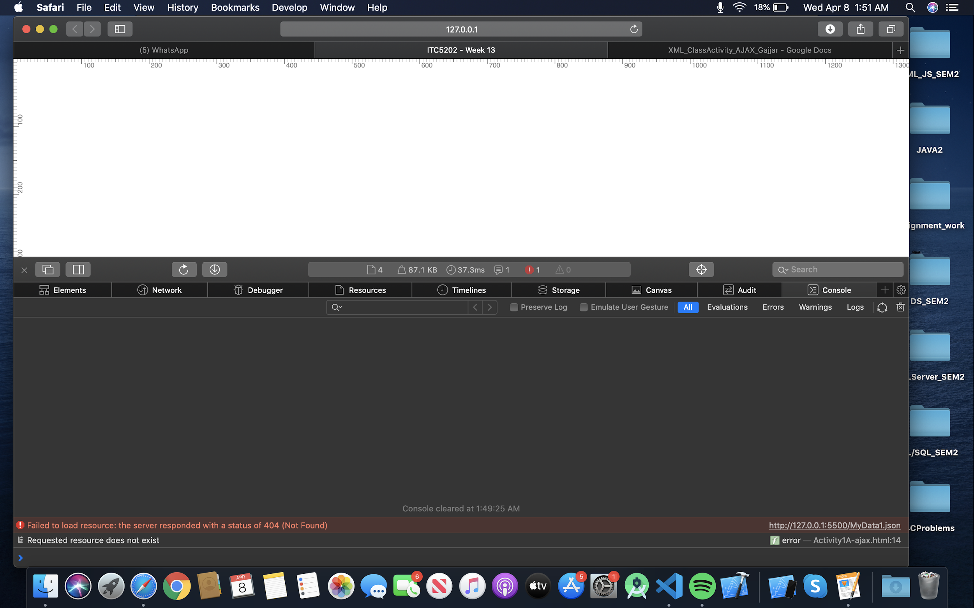

The main difference between the two codes is “done” has $.deferred implementation of ajax. This has a very important aspect from a code maintainability perspective.

We can add error message like this,

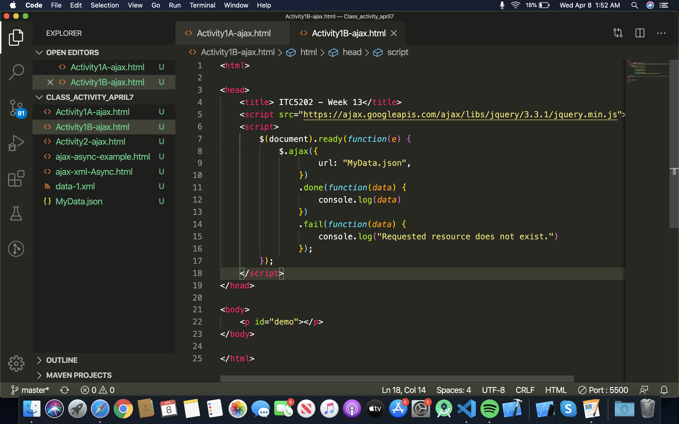

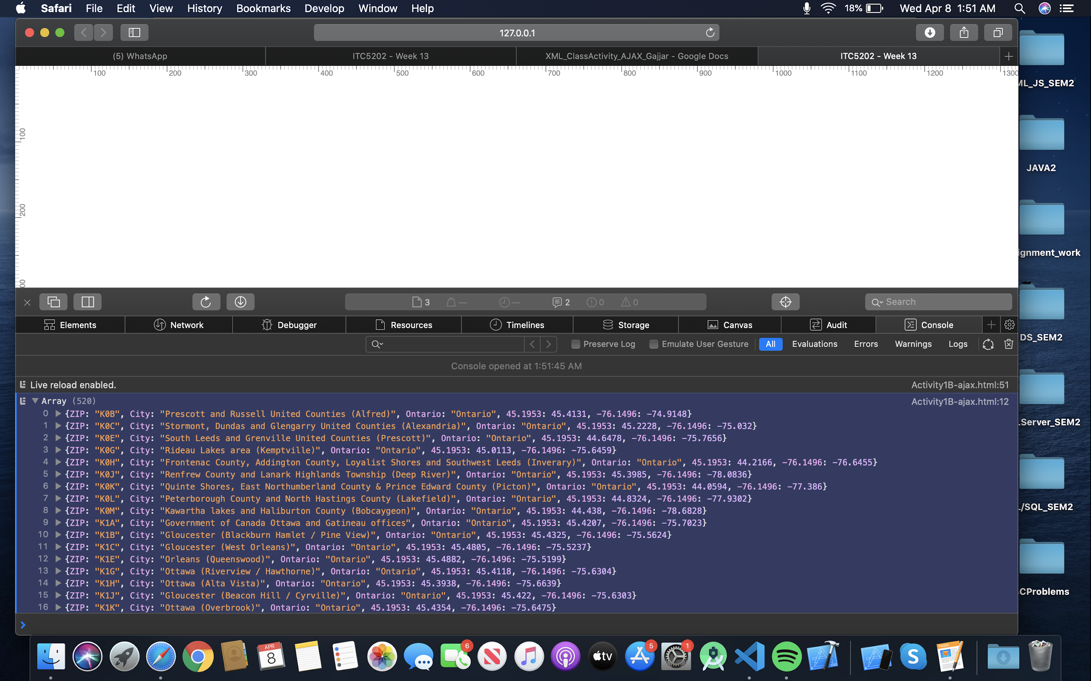

Activity 2

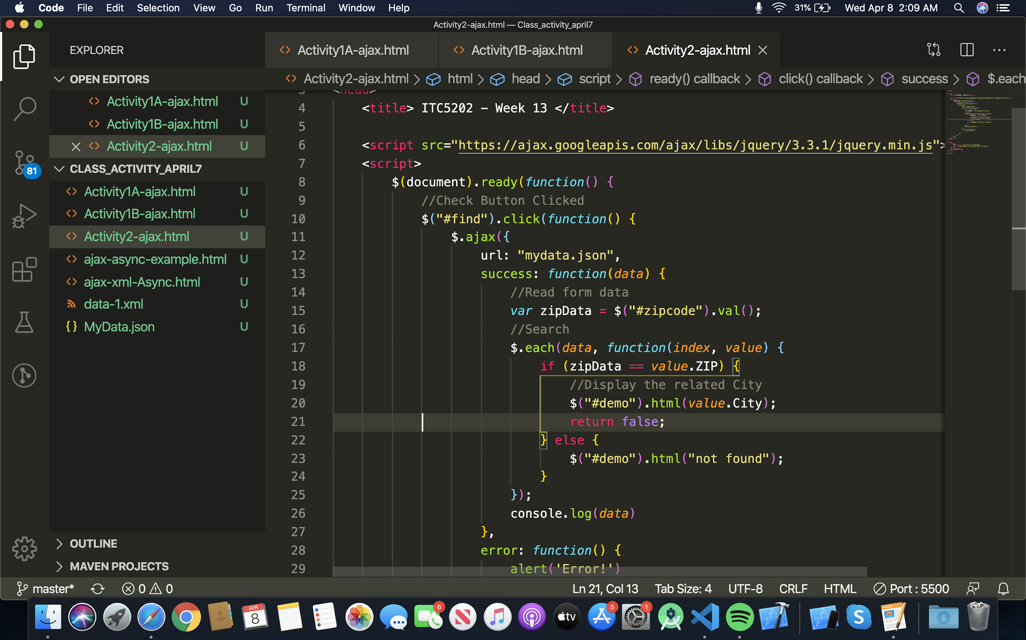

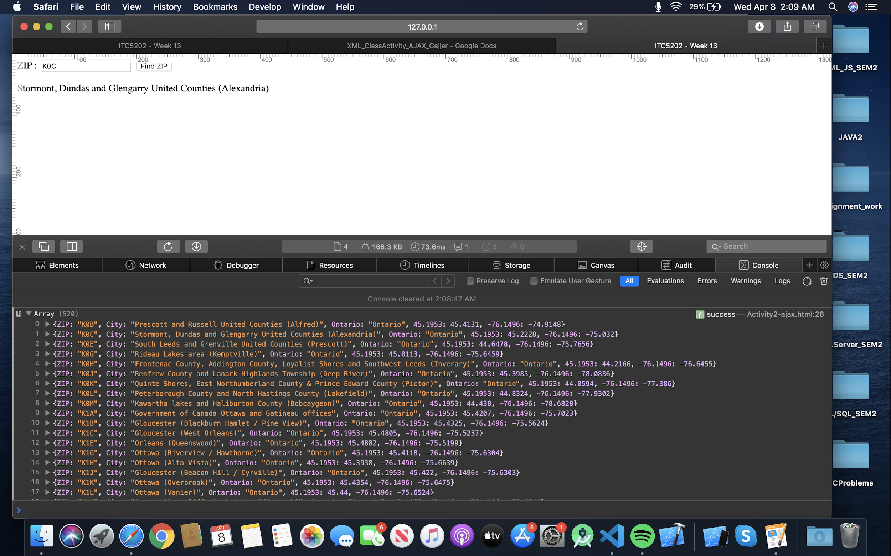

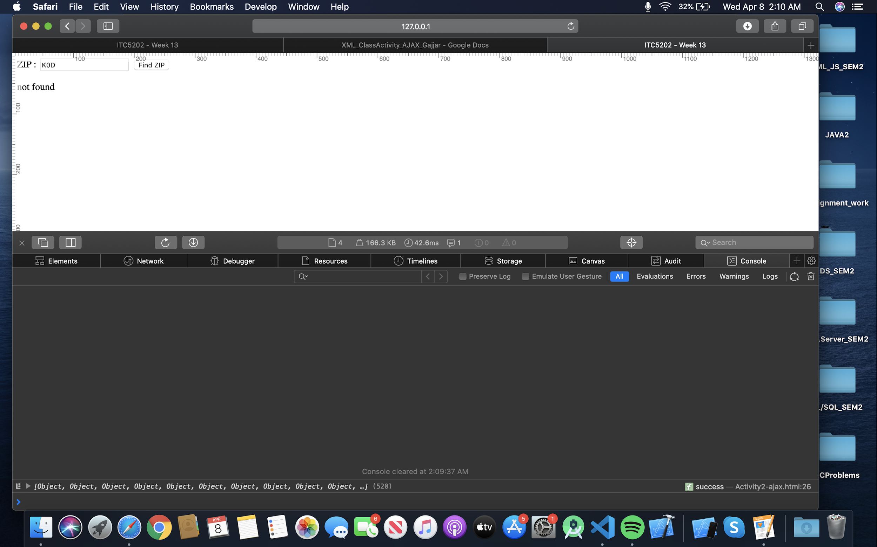

In this Activity we are finding information from the Json file by searching the zip code. We add a json file in the starting after that we used a success method in that we read data from the json file. For searching by the zip code we create an id and variable for zip. In $.each we add loop which compare the zip code with json file and if there are any match so it will fetch the data from that file by the #demo id it will display below the search box. If there is no match or file is not correct then we have error method which will display the error message.

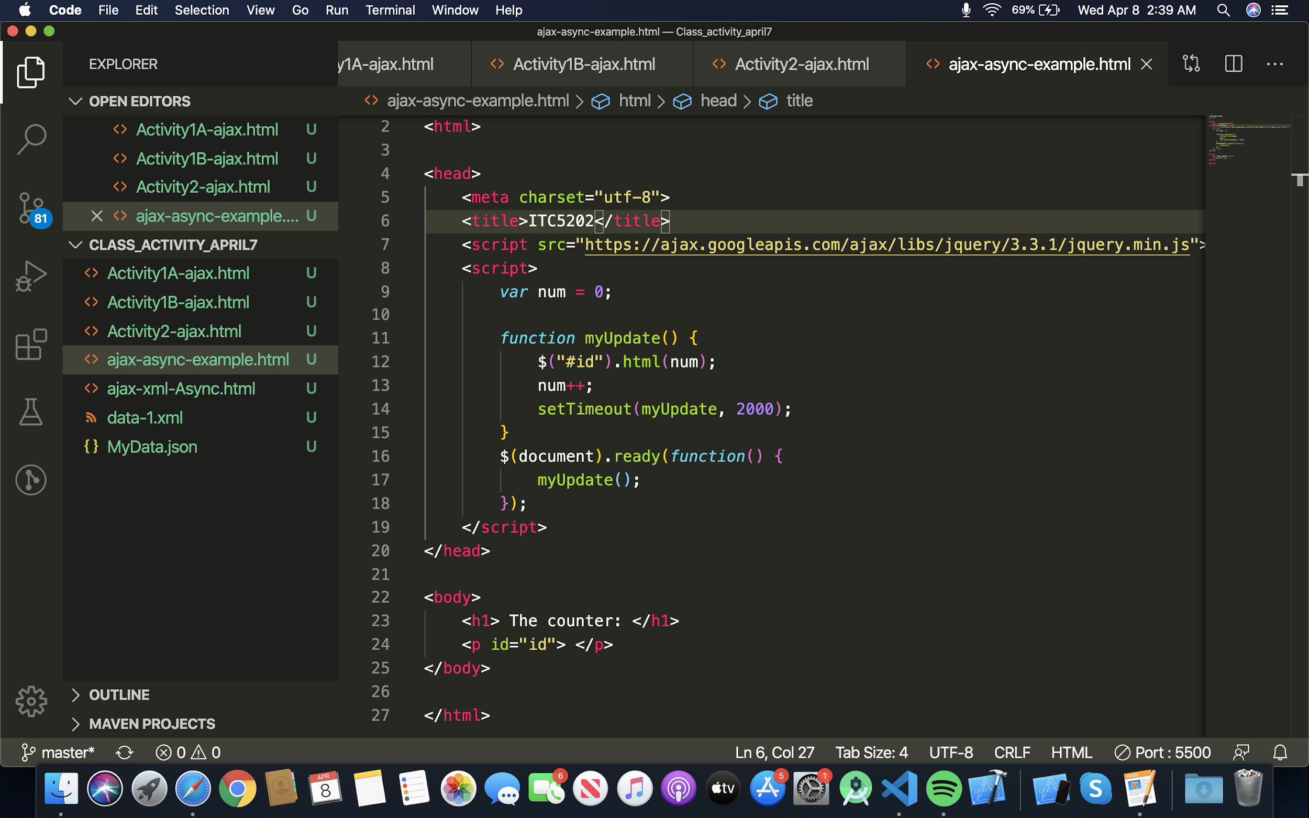

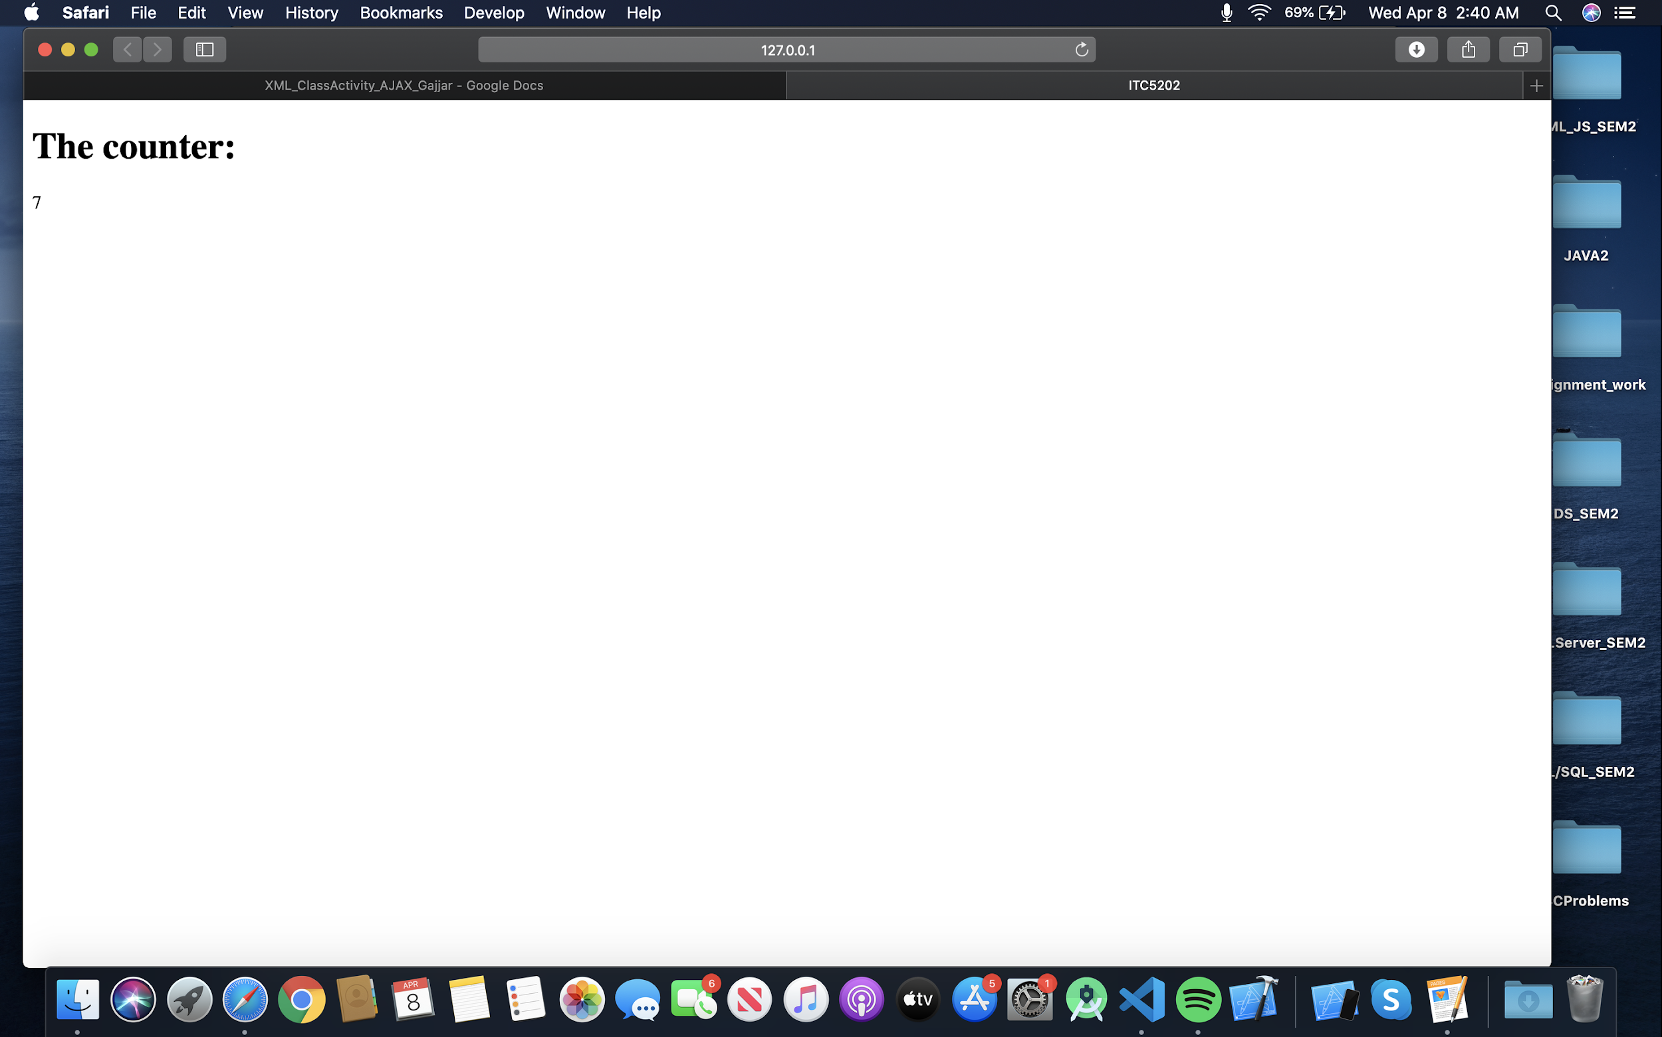

setTimeout calls the function myUpdate only once. Whereas setInterval keeps calling it multiple times. This works similar to a delay function with the program execution not having to wait for that much time.

Activity 3 :

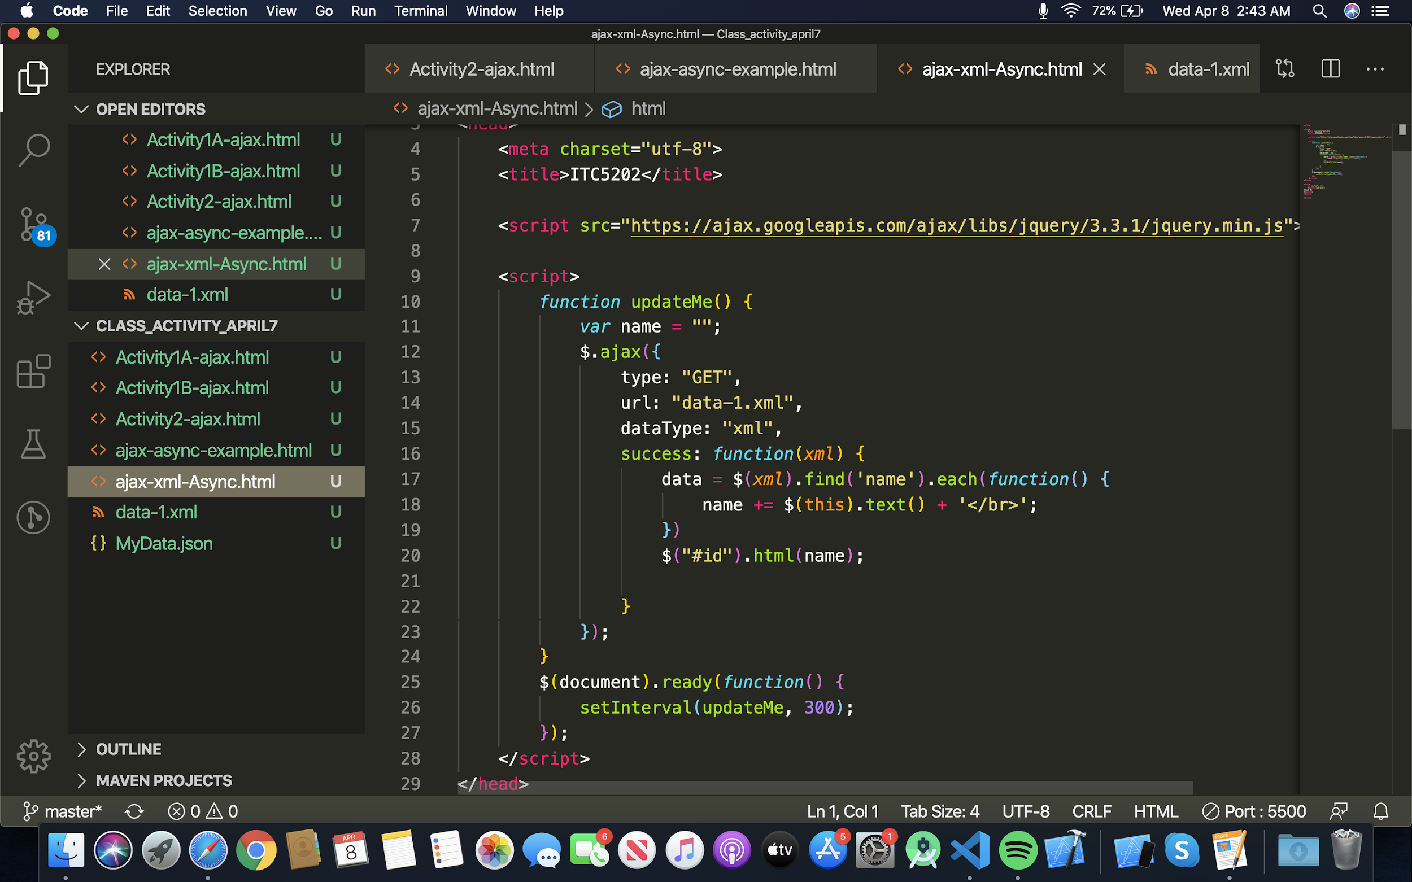

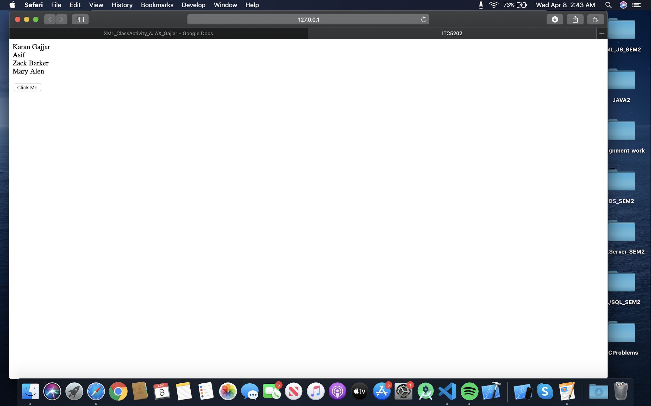

Activity 3 will work like a counter, in myupdate() function we add settimeout method by that method number will increase by 1 in every 2 second.

In this example we create updateMe function. We used a success method in it which will display the data from the Json file. By the setinterval() method we can update the data and we create a specific time period for that here we add a 300 milliseconds programme that will run every 300 milliseconds and update data if there is new data.